TEAM5OAGS

Team Project Report

Version 4.0

Signature Block

COSC 4351 | Name Signature | Date
SE Team Leader | Ryan Lee
SE SQA | Christopher Cruz
SE SQA | Muhammad Naviwala
SE Team Leader | Ryan Lee
SE SQA | Christopher Cruz
SE SQA | Muhammad Naviwala
SE Team Leader | Ryan Lee
SE SQA | Christopher Cruz
SE SQA | Muhammad Naviwala

Document Control

Change History

TLs entries (assigned work and due dates ) before releasing to the team
Revision | Name | Due Date | Description
1.1 | Ryan Lee | 02/01/2013 | Complete Chapter I
1.2 | Matthew Liang | 02/01/2013 | Complete Chapter II
1.3 | Christopher Berkowitz | 02/01/2013 | Complete Chapter III
1.X | Christopher Cruz | 02/05/2013 | Review Document
1.Y | Muhammad Naviwala | 02/05/2013 | Review Document
2.1 | Ryan Lee | 02/15/2013 | Complete Chapters IV, V
2.2 | Matthew Liang | 02/15/2013 | Complete Chapter VI
2.3 | Joel Loucks | 02/15/2013 | Complete Chapter VII
2.4 | Gabriel Ohlson | 02/15/2013 | Complete Chapter VIII
2.X | Christopher Cruz | 02/17/2013 | Review Document
2.Y | Muhammad Naviwala | 02/17/2013 | Review Document
3.1 | Christopher Cruz | 04/08/2013 | Perform revisions based on feedback from red and purple phases.
3.2 | Muhammad Naviwala | 04/08/2013 | Perform revisions based on feedback from red and purple phases.
3.3 | Christopher Berkowitz | 04/07/2013 | Chapter IX
3.4 | Ryan Lee | 04/07/2013 | Chapter X
3.5 | Yash Jaradi | 04/07/2013 | Chapter XI
3.X | Christopher Cruz | 04/09/2013 | Review document
3.Y | Muhammad Naviwala | 04/09/2013 | Review document

TMs entries when they completed their work
Revision | Name | Completed Date | Description
1.A | Ryan Lee TL | 01/30/2013 | Completed all of Chapter I paragraphs.
1.B | Matthew Liang TM | 01/30/2013 | Completed Chapter II
1.C | Chris Berkowitz TM | 01/31/2013 | Completed chapter 3 part A. More coming shortly.
1.D | Chris Berkowitz TM | 01/31/2013 | Completed chapter 3 part B.  More coming shortly.
1.E | Chris Berkowitz TM | 01/31/2013 | Completed chapter 3 part C.  More coming shortly.
1.F | Muhammad Naviwala SQA | 02/01/2013 | Reviewed Chapter 1, Chapter 2 and part of Chapter 3. Chapter 1 looks fine. For Chapter 2 part A and B, at some places it is hard to understand what you (Matthew) are trying to say, so I would suggest that you re-read it and make some changes to those 2 sections (2A and 2B). For chapter 3, it looks good so far, nicely explained but the tense used is “we” and it looks inconsistent because instead of “we”, “the team” is being used in this document. So it has to be consistent. I will be re-reading everything again in the next update.
1.F | Chris Berkowitz TM | 02/01/2013 | Added chapter 3 D,E,F.  Edits incoming.
1.G | Matthew Liang TM | 02/01/2013 | Rewrote Chapter 2 part A
1.H | Matthew Liang TM | 02/01/2013 | Add little changes to Chapter 2 part A. Fixed Chapter 2 part B
1.I | Chris Berkowitz TM | 02/01/2013 | Made “we” to “Team 5” changes.
1.J | Cruz Christopher SQA | 02/02/2013 | Read through, change a lot of grammar, punctuation. Reworded sentences, removed sentences that made no sense.
1.K | Muhammad Naviwala SQA | 02/02/2013 | Read through all the 3 chapters. Made some grammar changes and reworded sentences where necessary.
1.L | Christopher Cruz SQA | 02/05/2013 | Final Review, Looks great.
1.M | Muhammad Naviwala SQA | 02/05/2013 | Added the table of contents. Read through the 3 chapters. Looks good. Final review done.
1.N | Ryan Lee TL | 02/05/2013 | Team leader final review and approval for Red Deliverables.
2.1 | Ryan Lee TL | 02/08/2013 | Completed paragraphs for chapters 4 and 5.
2.B | Joel Loucks DBA | 02/10/2013 | Started chapter 7 A,B(i,ii). Just getting basic ideas down then will expand later.
2.C | Joel Loucks | 02/12/2013 | Started chapter 7, accidently started 6 last time, more to come later
2.D | Joel Loucks DBA | 02/12/2013 | Added more to chapter 7 A & B. Any grammar or written mistakes pointed out would be greatly appreciated!
2.E | Christopher Cruz SQA | 02/13/2013 | Read Chapters 4 & 5, edited grammar
2.F | Christopher Cruz SQA | 02/13/2013 | Read Chapter 6, edited grammar, sentences, changed some words. Added table of contents. Mo can you fix the leading periods? I couldn’t figure it out in word.
2.G | Joel Loucks DBA | 02/14/2013 | Added more to chapter 7. Any fixes of my grammar is appreciated.
2.H | Christopher Cruz SQA | 02//14/2013 | Corrected grammar, change some sentences.
2.I | Matthew Liang TM | 02/15/2013 | Added part 3 and 4 to chapter 6
2.J | Matthew Liang TM | 02/15/2013 | Added B.5, B.6, C, and D to Chapter 6
2.K | Muhammad Naviwala SQA | 02/16/2013 | Redid the table of contents
2.L | Christopher Cruz SQA | 02/18/2013 | Checked grammar, and sentence structure. Read through new additions.
2.M | Muhammad Naviwala SQA | 02/19/2013 | Read through the chapters. Changed some grammar and sentence flow. Chapter 6B-part 7 & 8 remaining. Chapter 7B-part 2, C & D remaining. Chapter 8 not started.
2.N | Matthew Liang TM | 02/27/2013 | Added Chapter 6B-part 7 & 8
2. O | Gabriel Ohlson DBA | 03/01/2013 | Added CH8 Problem Statement.
2.P | Gabriel Ohlson DBA | 03/01/2013 | Finished Ch8 with wireframes.
2.Q | Muhammad Naviwala SQA | 03/02/2013 | Read through the newly added content. Made some minor grammar changes. Now only part of Chapter 7 remaining.
2.R | Christopher Cruz SQA | 03/02/2013 | Read new sections, edited some grammar and reworded some sentences.
2.M | Christopher Cruz SQA | 03/04/2013 | Looks great. Signing off.
3.A | Muhammad Naviwala SQA | 03/22/2013 | Modified and completed the table of contents. Changed / Fixed the headings. Fixed the TEAM5OAGS issue by changing the font size where needed and adding it where needed.
3.B | Chris Berkowitz/TM | 04/07/2013 | Started and completed section IX.
3.C | Muhammad Naviwala/SQA | 04/08/2013 | Reviewed Chapter 9. Corrected some grammar mistakes. Updated table of contents. Changed the heading of Chapter 9 (Like mentioned in the feedback).
3.D | Christopher Cruz SQA |  | Reviewed CH 9, Corrected grammar and sentence structure. Also corrected roles in logs like mentioned in feedback.
3.E | Yash Jaradi TM | 4/10/2013 | Added the problem statements for chapters X and XI
3.F | Christopher Cruz SQA | 4/10/2013 | Read CH 10 problem statements, correct grammar and sentence structure.
3.G | Ryan Lee - TL | 04/10/2013 | Added chapter 10 diagram and concluding remarks.
3.H | Yash Jaradi TM | 04/10/2013 | Added Ch. X pseudocode  Added concluding remarks and deployment diagram fro XI
3.I | Matthew Liang TM | 04/10/2013 | Change the format of Psuedocode to make it compilable
3.J | Muhammad Naviwala / SQA | 04/10/2013 | Reviewed the new changes. Edited some formatting and changed some grammar.
3.K | Christopher Cruz SQA | 04/10/2013 | Reviewed new changes, looks good.
4.0 | Ryan Lee - TL | 04/10/2013 | Final signout

TLs entry before DELIVERABLES
Revision | Name | Due Date | Description
2.0 | Ryan Lee | 02/05/2013 | I changed Version to 2.0
3.0 | Ryan Lee | 02/18/2013 | I changed Version to 3.0
4.0 | Ryan Lee | 03/08/2013 | I changed Version to 4.0

Document Storage
This file is stored in SVN at http://limi.cs.uh.edu/COSC4351/TEAM5/TEAM PROJECT DELIVERABLES/Team Project Report.doc.

Table of Contents:
Chapter I: Introduction to TEAM5OAGS 8
A. Introduction 8
B. Research Methodology 8
C. Report Organization 8
Chapter II: Expanding the Requirements 9
A. Problem Statement 9
B. Expanding the Borders 9
C. Expanding vs Replacing the System 10
D. Concluding Remarks 10
Chapter III: Educating the User 10
A. The Software Process 10
B. Problems with Software Complexity 11
C. Problems with Software Conformity 11
D. Problems with Software Changeability 11
E. Problems with Software Invisibility 11
F. Concluding Remarks 12

Chapter IV: Choosing the Right Team 13
A. Problem Statement 13
B. Assembling the Team 13
- The Democratic Approach 13
- The Chief Programmer Approach 14
- The Modern Approach: Team Leader and Team Manager 15
- Additional Team Approaches 15
C. Recommendations 16
D. Concluding Remarks 16

Chapter V: Choosing the Right Model 17
A. Problem Statement 17
B. Comparing Models 17
- The Waterfall Model and the iterative and Incremental Approach 17
- The Extreme Programming Model 19
- The Synchronize and Stabilize Model 20
- The Spiral Model 20
C. Recommendations 21
D. Concluding Remarks 21

Chapter VI: Analysis and Development Methods 22
A. Problem Statement 22
B. Conventional Engineering Methods 22
- Stepwise Refinement 22
- Cost Benefit Analysis 22

Chapter VII: Testing 22
A. Problem Statement 22
B. Quality Assurance 23
- Non-execution-Based Testing 25
- Execution-Based Testing 27
C. Recommendation for TEAM5OAGS 27
D. Concluding Remarks 27

Chapter VIII: Developing TEAM5OAGS Master Page and Home Page 27
A. Problem Statement 27
B. TEAM5OAGS Master Page and Home Page 28
C. Concluding Remarks 29

Chapter IX: OO Analysis Models 30
A. Problem Statement 30
B. The UML Diagrams 30
C. Concluding Remarks 30

Chapter X: OO Design Models 31
A. Problem Statement 31
B. The UML Diagrams 31
C. Concluding Remarks 31

Chapter XI: Deployment Diagram 32
A. Problem Statement 32
B. The UML Diagrams 32
C. Concluding Remarks 32

Report Format and Content

Chapter I: Introduction to TEAM5OAGS

- Introduction
The purpose of this project is to construct a web application for an online art gallery. The company specializes in the selling of contemporary European and North American fine art such as lithographs, prints, paintings, and photographs. The web application that is to be constructed will allow customers to view and purchase artwork as well as services being offered by the company. The web application will also give merchants and former customers the opportunity to sell their artwork belongings to the company. By using standard software engineering principles and state of the art development tools, the goal of the team is to produce a high quality software product that will not only satisfy client’s business needs, but also help improve its business operations.

- Research Methodology
To determine the feasibility of the project to be undertaken, the team conducted a feasibility study and researched several websites that specialized in the selling of artwork. Examples of websites that were analyzed in the feasibility study were UGallery.com, artmajeur.com, redbubble.com, and 1-sharon-norman.artistwebsites.com. In the study, URLs for the websites and screenshots showing various user interface designs used by each site were compiled into a brief report and described in detail. Also, the web development framework, scripting languages, and servers that each website used were noted in the report. Finally, the team conducted a cost analysis for each website based on the data they have gathered and came up with the cost estimates for each website. Therefore, the team concludes that the project to be undertaken is indeed feasible and can be completed within the time and cost constraints that were estimated in the study.

- Report Organization
The purpose of this project report is to document and describe the various software engineering principles, tools, and practices that will be utilized in the team project. The report will be divided into ten subsequent chapters where each chapter will focus on a different topic of software engineering. Each topic will be discussed in detail by organizing chapter content with problem statements, body paragraphs, and concluding remarks. The problem statements will present the background information of the topic to be discussed and what issues may need to be addressed. The body paragraphs will elaborate about the issues presented by the problem statement and seek to address them by providing examples and potential solutions. And finally, the concluding remarks section will summarize the topic that was covered by the chapter and may include any recommendations that the team has made for the project.

Chapter II: Expanding the Requirements

- Problem Statement
History has presented software development as a challenging discipline with rare prospects of success. Although software engineers have been selective on applying theories, methods, and tools that are most appropriate, such practices have presented differences to the way software is developed. This often results in problems such as late delivery, being over budget, and software faults leading to unsuccessful (and unacceptable) outcomes. As TEAM5OAGS is developed, the team will apply the traditional software development practices and address issues from requirements to post-delivery maintenance in a technical and manageable fashion. From an economic perspective, software development comes with a high cost while significant progress has been made. In fact, most costs are associated with the maintenance of the product. For this reason, the team will be tasked with developing a product under a cost-efficient plan for both the company and the client. The product will undergo maintenance throughout the entire life-cycle to address corrections and improvements the software product may undergo.

- Expanding the Borders
A software product can be modified after delivery to correct faults, enhance performance, or add new functionalities. Maintenance is an essential phase in the software life-cycle because the majority of the costs are associated with the maintenance of the product rather than its development. Also, if maintenance is not done properly, the inability to update software quickly and reliably will result in a lost business opportunity and early retirement for the software product.

Post-Maintenance consists of four different types. First, corrective maintenance involves removing faults or defects while leaving the specifications intact. Next, enhancement maintenance is a software update consisting of the changes to the specifications and the implementation. Third, perfective maintenance involves improvements to the software that add more functionality and efficiency beyond the initial requirements. Lastly, adaptive maintenance involves updating the software product in response to changes in the environment such as new hardware or new government regulations.

The project will undergo corrective maintenance in cases where correcting faults is a necessity. However, the system may also undergo perfective maintenance for improvement oat the request of the client. Overall, promoting a maintenance-friendly product will be the team’s priority in terms of effort and spending so that the utility of the product to be developed can be enhanced.

- Expanding vs. Replacing the System
While it is important to maintain the software, perfective and adaptive maintenances play a big role as they are both essential for allowing the software product to evolve over time. During perfective maintenance, modifications to the software extend its functionality and improve its performance. This approach is carried out if a client wishes to add new features or modify it to run faster. Adaptive maintenance is performed when changes to the environment the system is running in occur. In such a case, it is imperative to update the system in order for it to fit in the new environment.

TEAM5OAGS will be addressed to handle such changes as the software is being developed. The maintenance will serve to update the system to adapt the new changes as well as surpass its initial requirements through enhancement. Maintenance is vital as it may influence and promote the extent to which this system was originally developed.

- Concluding Remarks
It is important to recognize that software engineering practices are to be performed skillfully and insightfully. At every step of the software development cycle, they must be conducted in a balanced-budgeted way.
But it is also important to keep maintenance in mind when developing the product because there are bound to be faults in the software. Maintenance will help ensure that these faults are handled in a way that does not affect the integrity of the product. Eventually, the software product will grow to its potential as changes need to be made.

Chapter III: Educating the User

- The Software Process
Developing software is an intricate process that becomes much more manageable with a plan. Team 5 will be using the Unified Process methodology to ensure the software process will be structured, on schedule, and that the final product will perfectly match the product specified. The Unified Process was chosen as the methodology due to its wide acceptance as the standard object-oriented guideline and also because it is easily adaptable to properly fit any individual software needs.

The Unified Process has five key workflows. These workflows are requirements, analysis, design, implementation, and test workflows. Strictly adhering to these workflows will ensure that TEAM5OAGS will be effectively completed. The Unified Process requires modeling throughout the entire Software Development Life Cycle. After receiving the TEAM5OAGS requirements document, Team 5 began modeling via textual analysis. The team has properly analyzed the requirements and created UML use cases, UML class diagrams, and a Model-View Controller structure suitable for this web application. Through constant communication with the client, Team 5 refined the UML models to best capture the entire domain of the application that the client has envisioned.

- Problems with Software Complexity
Designing software can spiral out of “complexity” control if allowed to do so. To combat this issue Team 5 has taken many steps to reduce the complexity as much as possible.

Each member of Team 5 completed the UML use cases and the UML class diagrams. Once complete, the document was refined from collaborated findings and created one perfect textual analysis that will help guide the development of this application towards the final deliverable. This will not only help lower the complexity of this process but will also keep the team on schedule for the checkpoints throughout the entire project. These models have also helped outline the exact specifications that TEAM5OAGS must have. Using these models and keeping communication constant amongst the team will greatly reduce the software complexity problem, and prevent other project hurdles such as scope creep and going over budget. Combining these processes and through continued use of the Unified Process, Team 5 will keep the software complexity issue at a minimum.

- Problems with Software Conformity
Problems with software conformity are constantly arising. Parts of a larger software system may be upgraded and find they no longer work within the old product as intended. This is a serious issue that can ruin a project, destroy a necessary process, and even close an entire business down. This project has taken multiple steps to avoid this issue. For this reason, this is why Team 5 has decided to follow the Model-View Controller format. This means that Team 5 will not have to have the product conform to other preexisting products, where integration issues could arise. Team 5 will create all of the parts and the MVC form will help the team maintain this application’s modularity for any future system upgrades.

- Problems with Software Changeability
To address the problems with software changeability Team 5 has decided to implement a few simple principles that will be followed throughout the entire SDLP. Team 5 is going to, as previously mentioned, use the MVC format for TEAM5OAGS. This will greatly reduce many issues regarding ease of changeability in the future. By keeping the code in the MVC form the parts of the system will be much more accessible and therefore changeable if need be. TEAM5OAGS will also be heavily documented and the team will ensure that this documentation takes place throughout the entire process. This will help the users and any future system upgrade with the ability to succeed and understand thoroughly exactly what is going on within the application.

- Problems with Software Invisibility
The problem with software invisibility lies within the actual software design itself. Team 5 has put considerable effort into creating TEAM5OAGS with the end user in mind. By keeping the application as modular as feasibly possible the application will allow for extended use of the core functionality while also catering to the ever-changing technology frontier. This affects invisibility because when the application is written there is no emphasis on the end users having any ideas on how the actual processes interact with one another. Instead, they only understand how to use the application for its intended purpose. To combat the issue of software invisibility, Team 5 has made the effort to train (and continue training in the future) the end user as for a larger understanding of the back end that is typically unrealized. This will allow for future modification if need be and a firmer understanding of why the program acts the way it does. Team 5 has also documented every action taken towards the completion of TEAM5OAGS so that any third parties who may need to modify any parts of this application will be able to understand the parts separately and as a whole. This will keep future maintenance and upgrade costs at a much lower rate than the typical software products being produced are costing.

- Concluding Remarks
The software process is a tedious process that leaves room for many problems throughout the entire cycle. Team 5 has taken an exuberant amount of precautions to deliver TEAM5OAGS without errors or flaws. With repeated communication with the client, Team 5 has gotten to understand exactly how TEAM5OAGS needs to function. Using the models and taking the necessary steps to refine the design and perfect the Model-View Controller methodology, Team 5 has hammered out a perfect model to follow during the coming design and implementations phases. TEAM5OAGS will not only work as the premier art gallery web application it is being designed for, but will also save the client on any future endeavors that the client may have in respect to the application.

Chapter IV: Choosing the Right Team

- Problem Statement
Software products are often too large to be developed by one person within the given time constraints. Although the quality of a software product may be higher if it is developed by one professional, the amount of time it would take to accomplish the task would most likely be unfeasible. In addition, Miller’s Law states that the human brain is only capable of processing several chunks of information at a time. Therefore, large software products must be developed by a team of software professionals.

- Assembling the Team
There are several types of teams that software professionals can form. First, this report will focus on the two classical approaches to forming teams and discuss the nature of such teams as well as their advantages and disadvantages.

- The Democratic Approach
The democratic team organization was first described in 1971 by Weinberg. He pointed out that the basic concept underlying the democratic team was egoless programming. Egoless programming describes how programmers are supposed to be neutral to the code they write and not see it as an extension of themselves. For instance, a programmer who is passionate about his or her code would be more reluctant to see something wrong with it in the event a bug is uncovered. This form of attachment to the code that programmers write increases the likelihood that unnoticed bugs will be introduced into the product and thereby decreasing the quality of the software product.

The democratic team approach is to have each member perceive the modules that are developed as part of a team rather than belonging to any one individual. Members are encouraged to find faults in their code and accept that the presence of faults does not imply anything bad about them. Rather, the presence of faults in code is considered a normal event that is to be expected and reviewers should not ridicule programmers who actively seek to find faults in their code.

A final aspect of democratic teams is that all members work for a common cause with no “leaders”; in other words, each member works for what is best for the team. In most workplace scenarios, the promotion of a programmer to a management position often results in his or her fellow programmers striving harder to attain the higher level at the next round of promotions. This is a case where team members are not necessarily concentrated on the best interests of the team; instead they are focused on attaining higher levels of position. In a democratic team, no team member works for the sole intention of attaining higher positions in the company hierarchy. Instead, members work together as a single unit to accomplish the software projects they are responsible for.

Overall, the benefits of democratic teams lead to the production of higher quality software products. Since the attitude towards the finding of faults hidden in the code is positive, each member is highly motivated to debug their codes with high scrutiny. Unfortunately, the democratic team approach is not without its shortcomings. It is impractical in environments where managers and programmers are reluctant to accept egoless programming. It is also impractical in environments where experienced professionals will be working with inexperienced programmers who appraise their code. Although the democratic team approach leads to higher rates of productivity, its impracticality in environments where competition is present among professionals makes it hard to implement.

- The Chief Programmer Approach
The chief programmer approach was put forward by Brooks in 1975 when he analogized the chief programmer team to a team of surgeons who were operating under the direction of the chief surgeon. However the chief programmer team is not just limited to the expertise of the chief programmer; other experts in different fields of practice may be introduced if necessary.

There are two key aspects of the chief programmer team. The first is a concept called specialization. Specialization refers to a situation where each member of the team carries out only those tasks for which he or she has been trained. For instance, the DBA member of a team will be solely responsible for handling the program’s interactions with the database rather than the programming logic of a graphical user interface. The second aspect is hierarchy. Here, the chief programmer directs the actions of all other programmers and is responsible for every aspect of the operation.

The chief programmer is considered to be both a highly successful manager and a highly skilled programmer who is responsible for the architectural design and any critical sections of the code. Usually the chief programmer would be assisted by a backup programmer of similar (but less) expertise. In the event the chief programmer had to take a leave of absence there would be someone familiar with the project to replace them. The other programmers on the team work on the detailed design and the coding under the direction of the chief programmer. In addition, a programming secretary (also called a librarian) is responsible for keeping up with the documentation of the entire project, which often included a copious amount of paperwork. No lines of communication existed between programmers since all interfacing issues were often handled by the chief programmer. Finally, the chief programmer reviewed the work of the other team members since the chief programmer was responsible for every line of code written.

The chief programmer approach, though it had its shining moment in 1971 with the success of an IBM project associated with the New York Times, is for the most part impractical. This is because it is extremely difficult to find a professional who is both a highly skilled manager and a skilled programmer. Also, finding similarly skilled backup programmers in the even the chief programmer leaves is even more difficult. And finally, the team approach is impractical for projects that will require more than twenty professionals to develop since the amount of interfacing required of the chief programmer will most likely be burdensome.

- The Modern Approach: Team Leader and Team Manager
Professionals who are highly skilled in both managerial and programming duties are hard to find in copious numbers to make chief programmer teams practical. The chief programmer is personally responsible for every line of code written and therefore must be present at code reviews. In addition, as a manager, the chief programmer is responsible for the evaluation of team members, which makes the presence of the chief programmer at a code review inadvisable. After all, senior members of a team resent having their works being appraised by less experienced members.

The solution to the problem of the classical chief programmer team approach is to replace the role of the chief programmer with two professionals: a team leader in charge of the technical aspects of the team’s activities and a team manager responsible for the managerial duties. The responsibilities of each leader is within the scope of his or her area of expertise. The team leader is responsible for the technical management while the team manager is responsible for duties such as budgetary, legal, and performance evaluation issues. The team leader will be a natural participant in all code reviews while the team manager will be absent since performance appraisal is solely the duty of the team manager.

If a project is large enough, there may be multiple team leaders introduced. Each team leader will be responsible for the technical management of a number of programmers while at the same time be answerable to a single project leader. The nontechnical side is similarly organized. Implementation of the product as a whole is under the direction of the project leader. If the project being undertaken requires a synergistic effort of the team, then channels of communication between each member of the team can be introduced with communication channels from senior members pointing downward to their subordinates. This allows for a more decentralized system of decision making.

- Additional Team Approaches
Alternative approaches to team formation exist with the more recent synchronize-and-stabilize, agile, and open-source programming teams. A well-known practitioner of the synchronize-and-stabilize team is Microsoft. Since the size of the products Microsoft develops is often large (with products containing more than 30 million lines of code being common), the team approach is largely a consequence of the way teams are organized.

The synchronize-and-stabilize model is described by the following scenario: the three or four builds of a synchronize-and-stabilize product are constructed by a number of small parallel teams being led by a manager. The teams consist of several developers working with several testers who work one-to-one with the developers. The teams are provided with the specifications of the product and the members are given the freedom to design and implement their portions of tasks as they see fit. The partially completed components at the end of the day are then put together, tested, and debugged. In this environment, individual creativity and autonomy are encouraged and the components often work together.

The primary strength of the synchronize-and-stabilize model is that creativity and innovation are encouraged, a characteristic of the democratic team. In addition, the daily synchronization step ensures that the developers are working towards a common goal without requiring the communication and coordination of a chief programmer team. While this team approach has been highly successful for Microsoft, it is unlikely to be successfully implemented outside the company since it requires a high concentration of talented managers and software developers.

- Recommendations for TEAM5OAGS
The team recommends that the democratic team approach be used due to the small number of members needed to develop the TEAM5OAGS web application. Such a team organization will allow for members to not only actively search for faults within their own code, but also become actively involved in pursuing the team’s overall goal. Driven by egoless programming and high fault detection rates, the team believes that the goal of producing a high quality software product TEAM5OAGS can be attained within the time and cost constraints.

- Concluding Remarks
Various team formation approaches exist for software professionals, each with their advantages and disadvantages in terms of practicality. Democratic teams, although highly productive in finding faults as well as delivery of high quality software, are often impractical in workplace environments where competition exists between employees. Chief programmer teams are impractical in light of the shortage of professionals who are highly skilled in both management and programming. Therefore, the most common approach being used in software development is the team manager and team leader approach.

Chapter V: Choosing the Right Model

- Problem Statement
A software life-cycle model is a description of the steps that should be performed when building a software product. Since it is almost always easier to perform a series of smaller tasks than one large task, each life-cycle model is broken down into a series of smaller steps called phases. The six classical phases of software development include the following: requirements, analysis, design, implementation, post-delivery maintenance, and retirement. All software life-cycle models incorporate these phases, although the order or level of focus of each phase may vary from model to model. In this chapter, five software life-cycle models will be discussed in detail: waterfall, incremental, extreme programming, synchronize and stabilize, and spiral.

- Comparing Models
- The Waterfall Model and the Iterative and Incremental Approach
The waterfall life-cycle model is a classical model that dates back to 1970. It includes all six classical phases of software development and typically a project follows the phases in strict sequential order. The critical aspect of the waterfall model is that no phase is complete until the documentation and testing for the phase being worked on has been completed and reviewed thoroughly by the SQA group. This carries over into modifications; for instance, if the products of an earlier phase have to be changed, then the project must proceed back to the affected phase and the modifications must be performed. In addition, any subsequent phases after the affected phase may need to be updated and checked/tested by the SQA group. Testing is not inherent to any one phase; rather it is performed throughout the entire life-cycle of the product.

The ideal application of the waterfall model would be that the software would be developed in discrete phases (namely the six classical phases.) However such an ideal application is impractical if not realistic in the present world. Instead, application of the waterfall model follows an iterative and incremental approach. Here, the software product (assuming too large to be handled by one professional) is broken down into smaller parts called modules. Each module would then be handled by a team of developers and undergo the six classical phases in sequential order that makes up the waterfall model. Each undergoing of the six phases would take place in an iteration. Iterations take place when one artifact is produced and is later revised to produce a second version and so on. With each iteration, it is the team’s goal to ensure that the new iteration is closer to the desired target (satisfaction of specifications) than its predecessor. When a final version of the module is produced and satisfies its specifications, then the iteration for that module ends.

Incrementation is the process of constructing an artifact (whether it be a module or the entire software product itself) piece by piece. These pieces used to construct the artifact are the results of a series of successive iterations, with the final iteration yielding the completed, satisfactory product. The goal is to have all of the modules that are individually constructed through iterations be put together through many increments to constitute the entire software product. This is accomplished by stepwise refinement, which is the process of concentrating on developing the most critical aspects of the software product first before moving on to the less critical aspects.

The waterfall model’s strength lies in the fact that each phase of development is heavily documented, reviewed, and tested by the SQA group. Such a practice would help ensure that the software product being developed is able to meet its targeted specifications. However, the waterfall model has serious weaknesses that make it impractical to be implemented in most professional settings. First, the waterfall model relies on the specifications being static over time. In other words, the specifications must not change over time. The problem associated with changing requirements by the client is often called the moving target problem. The waterfall model is notoriously vulnerable to delivering software products that the client initially asked for, but not what they wanted in the end.

In addition, the waterfall model is a rigid model that is inflexible to changing requirements. As requirements are changed over time, certain phases of software development are affected and as a result, the module being worked on or even the entire project must come to a halt. The developers must suspend their current work and go all the way back to the affected phase to make corrections and updates in light of the new requirements. In addition, they must also perform updates for the subsequent phases that are affected as a result of the changes. This process has the unintended effect of delaying the project, which could cause the developers to miss their targeted release date. Such a release delay might not only decrease the level of confidence of the client organizations, but also open up potential situations for litigation.

Overall, the current application of the waterfall life-cycle model follows an iterative and incremental approach, although its true and idealistic application would not. Some authors go as far as saying that the waterfall and iterative and incremental models are one and the same. This is only true because the waterfall model is applied in an iterative and incremental approach. Although the waterfall model has its strengths in delivering a software product that meets its client’s needs, its strength relies on the condition that the requirements remain static over time. Such a condition is highly unrealistic, especially when the activities of a client business could change. In addition, the dilatory effects introduced by such requirement changes make the waterfall model rigid and inflexible for developers. As a result, current application of the waterfall model in the industry is rare.

- The Extreme Programming Model
Extreme Programming is an agile development practice that is fairly new to software development. Like the waterfall model, extreme programming has its application based on the iterative and incremental approach.

The first step that the software development team takes is determining the various features the client would like the software product to support. These features are called user stories. For each feature, the team then informs the client the feasibility of the feature, how long it will take to implement it, and how much it will cost. This first step corresponds to the classical requirements and analysis workflows of software development. Based on cost-benefit studies, the client then selects the features to be included in each successive build. The proposed build is then broken down into smaller pieces called tasks. Each task has its test cases drawn up by a programmer; this is called test-driven development. Then two programmers work together on one workstation in implementing the task and ensuring that all the test cases work correctly. This is called pair-programming, an inherent feature in agile development. Each programmer takes turns in coding while the other checks the code. Overall, the implementation of tasks would be done in parallel to ensure that integration is continuous.

Another feature inherent in extreme programming is refactoring. Refactoring is the process of changing the internal structure of a code artifact without altering its external behavior to improve some of the nonfunctional attributes of the software. Since extreme programming (and agile development in general) does not contain a phase dedicated to design, changes in design to an artifact of a product take place by refactoring. When a test case does not run, the code is refactored until a design that is simple and straightforward runs all the test cases correctly.

Implementation takes place much earlier in extreme programming because working software is one of the measurements of progress among agile developers. In addition, the constant delivery of bits of working software to the client helps elicit feedback that can guide future development efforts. Since the delivery of working software is one of the principles of agile development, one of the goals of agile developers is to set iteration deadlines for implementing tasks. This is called timeboxing and typically the iterations will last approximately three to four weeks. If the task cannot be implemented within the time constraints, then a reduced feature will be delivered. Eventually the iterations release increments to the client will constitute the entire software product to be delivered to the client. In fact, it is possible that given enough increments, the client may be satisfied and further development may not be necessary. As such, extreme programming is often associated with delivering only the features the client needs and nothing more.

- The Synchronize and Stabilize Model
The synchronize-and-stabilize life-cycle model is a version of the iterative and incremental approach to software development that is used almost exclusively by Microsoft. Due to the presence of synchronize-and-stabilize teams in Microsoft, the company has been able to implement this model with significant success.

The synchronize-and-stabilize model begins with the developers interviewing numerous clients and extracting a list of features of highest priority. Specification documents are drawn up and work is divided into several builds by order of criticality. Each build is carried out by a number of small teams working in parallel and at the end of the day, all teams synchronize their builds. That is, they put the partially completed components together and test and debug the resulting product. Faults are detected and at the end of the day, the build is frozen (stabilization) and no further changes will be made to the specifications. The repeated synchronization steps help guarantee that the various components constructed will always work together.

- The Spiral Model
The Spiral Life-Cycle Model is a model that combines the idea of iterative development with the systematic, controlled aspects of the waterfall model. It allows for incremental releases, or improvements, through each time around the spiral and thus is appropriate for large scale projects. Essentially, the spiral model can be viewed as the waterfall model with each phase followed by risk analysis. Risk analysis is performed to mitigate the risks that are associated with each phase. If the risk cannot be mitigated to an acceptable level, then either the specifications are changed or the project is cancelled.

The spiral model makes use of prototyping for providing certain classes of risk. For example, prototyping can be used to measure whether a conceived product can perform within a certain time constraint. If the prototype cannot achieve the desired results, then it is likely that the product to be developed itself may not be able to as well. This information offered by prototypes help give developers a good idea over the feasibility of mitigating certain risks. There are, however, other types of risks that cannot be modeled by prototypes. For instance, the risk that the software personnel needed to develop a product cannot be hired or that the necessary hardware to construct the product is not delivered on time are risks that are not amenable to prototyping. As such, not every risk analysis that precedes a development phase in the spiral model involves prototyping.

The spiral model of software development has a number of strengths. First, it incorporates software quality as an objective. Second, it is a risk-driven process. No phase is worked on until the proper risk analysis studies have been completed. This check ensures that development efforts on large projects do not go to waste if certain conditions cannot be met, saving potentially huge sums of money. However, the spiral model has restrictions in that it can only be used for large scale projects and that only professionals skilled in risk analysis are hired. There is nothing worse than a team believing that all is well when their project is in reality heading for disaster. In addition, the spiral model, like the waterfall model, assumes that the software product is developed in discrete phases when in reality it is not. Instead, software development follows an iterative and incremental approach.

- Recommendations
After reviewing the five software life-cycle models and scrutinizing their characteristics as well as advantages and disadvantages, the team will develop the software product TEAM5OAGS using the iterative and incremental approach. Such an approach is not only widely used, but also practical for developing applications that require stepwise refinement. In addition, the iterative and incremental approach will allow the team to develop code artifacts that not only satisfy their specifications, but also integrate together to form a high quality software product.

- Concluding Remarks
Overall, five life-cycle models have been studied in detail with their various features described. The waterfall, extreme programming, spiral, and synchronize-and-stabilize models all share the common characteristic of being applied in the iterative and incremental approach rather than the classical approaches they may prescribe. For instance, the waterfall and spiral models assume that software development undergoes discrete phases when it does not. However, the spiral model is an ideal model for designing large-scale applications involving high risk while the waterfall model is ideal for projects with static requirements. In addition, the iterative and incremental models such as extreme programming and synchronize-and-stabilize models offer features endemic to them. While various life-cycle models exist in software development, it is important for the team to choose the appropriate model for development as there is no one size fits all solution.

Chapter VI: Analysis and Development Methods

- Problem Statement
A CASE tool, which is an acronym for Computer-Aided Software Engineering, helps software engineers in every phase of the development process from conceptualization to implementation.

B. Conventional Engineering Methods
i. Stepwise Refinement
Stepwise refinement is defined as a means to postpone decisions on details until as late as possible to concentrate on the importation issues. This is important because Miller’s law states that the human brain can only concentrate on approximately seven things at a time, which makes building a software product in one step unreasonable. One of the difficult tasks with stepwise refinement is deciding what are the important issues in each step. A certain task may not be important early on in development, but as each step of development progresses that task may become crucial and therefore would need to be focused on.

ii. Cost Benefit Analysis
Cost Benefit Analysis is a way of determining whether a possible course of action would be profitable by comparing estimated future benefits against projected future costs. This analysis is important in determining if a software product, with the cost of hardware, is economically beneficial to an organization.

When analyzing the benefits of automating a clients business, assumptions must be made in order to determine the initial cost of set up and the long-term savings of having an automated system. This includes what type of product that is developed and how the data is stored.

iii. Software Metrics
Throughout the software process, the software metrics can detect the problems early on so that the potential problems would not become serious later on. Out of many different metrics, product metrics and process metric are two most important measurements. Product metrics measure the aspects of a product, while process metrics are used by developers as a means of finding problems during their software process. A software company should always use the five essential fundamental metrics: the size on the lines of code, the cost in dollars, the duration in months, and the effort done by person given months and the quality with the number of faults detected. Such metrics are applied by the given workflow and addresses the problems within the software company such as high fault rates during the design workflow.

iv. CASE
Computer-aided software engineering, or CASE, can assist an individual to carry out different tasks with ease but does not automate process for a user. Tasks such as documentation are not typically pleasant to work with, but with computers, it can make a difference in handling long process. CASE can support managers and developers to cope the complexity of software development in managing detailed information for easier access. While it makes development more manageable, computer is just a tool for aiding. The development and maintenance of software still requires human intervention.

v. Software Versions
A software product in maintenance has an old version and a new version. The new version, namely the “revision”, is built upon multiple versions since software has been installed with improvements and upgrades. Nevertheless, any old version should not be thrown out because the new revision does not guarantee a better product than the old. Not all will use the latest version of the product due to incompatibility or preference. Also, it is still necessary in case of finding fault in the old version in order to correct the issue. Hence, it is needed to keep a copy of every revision of each artifact.

Unlike revision, variations are created and implemented particularly to replace or coexist with the former variation. Also, variations are needed to create a new version to run on different hardware platforms and operating systems.

vi. Configuration Management
The configuration of the product has the specific version of each artifact from which a given version of the complete product is built. Every artifact consists of codes in three forms: source code (generally implemented in a high-level language like C++ or java), object or compile code (produced by compiling the source code), and executable load images (resulted from complied coded combined with run-time routines).

When an artifact failed on a specific set of test data, programmers attempt to re-create the failure and determine which versions of which variations that produce the error in the product. A version-control tool is one of the solutions that are able to manage multiple versions of artifacts and the product as a whole when a derivation of every version in the artifact is received. A derivation is a detailed report composed of name of each source code, variation and revision, versions of various compilers and linkers used, the name of the person who constructed the product, and the date and time at which it was constructed.

Another is the configuration-control tool which can automatically manage multiple variations and handle problems caused by the development and maintenance by teams when working on a fault. Configuration-control is usually needed to ensure any new version is correctly embedded into the artifacts during the post-delivery maintenance and the implementation phase. For instance, to search for a fault, a baseline, or configuration of all artifacts in a product, must be set up by the maintenance manager and reserve copies of any artifacts into a programmer’s private workspace. The programmer can make any changes in their workspace without impacting other’s work. Programmer can freeze the process of the current version of the artifact, so other programmers cannot make any changes to it. Once the changes is made and tested, the new version is installed and the resulting artifact becomes the next baseline version. Changes made to an integrated artifact can affect the product as a whole.

vii. Problem Statement
Though CASE is a tool to assist an individual, the user needs to have the experience in handling one with proper care. There is a saying that “a fool with a tool is still a fool” [Guinan, Cooprider, and Sawyer, 1997]. Therefore, it is vital that users are trained to know their tools well. When training is complete, performance and software quality would improve. Such result justify that CASE Environments should be used at least at maturity level 3.

viii. Other Applicable Engineering Tools
On the other hand, programmers have used other tools such as Email, Spreadsheets, and Word processor to carry out general task. Coding tools provide some good assistance when it comes to providing data dictionary, checking code, and generating report or screen. To assure that the codes written are consistent, readable and errorless, programmers need to have tools like structure editor, pretty printers, online interface checkers, source-level debugger, etc. Structure editor is a text editor that can identify syntax faults in the code without compiling. Pretty printer indents the amount of appropriate spacing to format the code as readable as possible. Online interface checkers is a helping facility which can immediately flag on faults within a method. Developers also use source-level debugger to automatically trace the output to be produced.

C. Recommendation
Upon reviewing a number of analytical tools, it is recommended that the Team Project should take advantage of these tools as they give benefits of organizing and scopes to the development. The team will be able to form a high quality software product while performing a stepwise refinement, analyzing the cost-benefit, measuring the process with software metric, using CASE, building and maintaining multiple versions, and managing configurations.

D. Concluding Remarks
In conclusion, the conventional tools help improve productivity and provide organization for software engineers. These tools are worth investing because they are used as a means of accomplishing a task or purpose while keeping the development effective and efficient in the overall process.

Chapter VII: Testing

A. Problem Statement
Testing is an essential part of the software development process. Most software life cycles have a separate testing phase that takes place at the end when the product is being integrated and before post delivery maintenance. This is a major problem for a software product because there could be faults, design flaws and even missing requirements. The terms verification and validation are sometimes used to define this process but are insufficient because they imply that testing should be done at the end of the life cycle, which as stated before, can lead to problems. This is why testing should be carried out during every phase to make sure all the requirements are met, that the design does not have any faults, and that there are no residual faults. There are two types of testing; execution-based testing and non-execution based testing, both of which will be discussed here.

B. Quality Assurance
Faults can happen during every phase of development, and a way to cut down on those faults is to have a dedicated SQA group. The SQA group’s job is to ensure that the product is of high quality and establishes the standards to which the product must conform. When developers finish a workflow the SQA’s must ensure that the workflow was completed successfully and with high standards. It is not the SQA’s responsibility to ensure the product is correct, that is the responsibility of every developer on the team.

i. Non-execution-Based Testing
Non-execution-based testing is where the software is tested without running test cases, reviewing software by reading through it and analyzing software mathematically. Performing reviews of the documentation and requirements with other skilled members of the team called walkthroughs or inspections. The people involved in these walkthroughs would be a representative of the team that drew up the specifications, a manager responsible for the analysis workflow, a client representative, a representative from the team that will be working on the next workflow, and a representative from the SQA group. Since the SQA group is in charge of the quality of work involved in each workflow, the SQA representative should be in charge of the meeting to make sure that faults do not slip through and that the walkthrough is performed correctly since the SQA’s have the most to lose if the product is not up to standards. The whole point of the walkthrough is to point out faults that need to be fixed after the meeting so those in attendance do not waste time. Therefore the walkthrough should be a short meeting and not last longer than 2 hours.

There are two way to conduct the walkthrough, participant driven and document driven. Participant driven is where the attendees present their list of unclear items that they think are incorrect while the representative of the analysis team responds to each query and clarifies what is unclear and if the incorrectness in question are actually faults. Document driven is where the person or team responsible for the documents walk the attendees in the meeting through the document and the reviewers interrupt the review with premeditated questions or questions that come up during the presentation. This type of review is usually more thorough because of the group dynamic of having more eyes on the document and with the presenter vocalizing the document and finding faults that they had not caught before. The primary reason for these walkthroughs is for it to be an interactive process made by the whole review team to find faults and corrections during each phase.

The last way of conducting non-execution based testing is by inspections, and is usually more thorough than walkthroughs by following five steps. The first step is the overview, where the document that is to be inspected is given by one of the individuals responsible for producing that document. At the end of the overview session, the document is distributed to the participants. The second step is in preparation where the participants try to understand the document in detail. Lists of fault types found in recent inspections, with the fault types ranked by frequency, are excellent aids. These lists help team members concentrate on the areas where the most faults have occurred. The third is when the inspection begins; one participant walks through the document with the inspection team, ensuring that every item is covered and that every branch is taken at least once. Then fault-finding commences. As with walkthroughs, the purpose is to find and document the faults, not to correct them. Within one day the leader of the inspection team must produce a written report of the inspection to ensure meticulous follow-through. The fourth step is in the rework, the individual responsible for the document resolves all faults and problems noted in the written report. The last step is the follow-up where the moderator must ensure that every issue raised has been resolved satisfactorily, by either fixing the document or clarifying items incorrectly flagged as faults. All fixes must be check to ensure that no new faults have been introduced. If more than 5 percent of the material inspected has been reworked, then the team must reconvene for the 100 percent re-inspection.

- Execution-Based Testing
Execution based testing in defined as the process of inferring certain behavioral properties of a product based, in part, on the results of executing the product in a known environment with selected inputs. While this kind of testing might seem like the end all it has several troubling implications. “Program testing can be a very effective way to show the presence of bugs, but it is hopelessly inadequate for sowing their absence” [Dijkstra, 1972]. Using “selected” inputs and a “known environment” for testing does not reflect the real world use of most programs. Sometimes a program has no control over what type of inputs are being received, like in flight systems, to be able to adequately test all aspects of the product.

So what should be tested? Execution based testing tests five aspects of a product, utility, reliability, robustness, performance, and correctness. Utility is the extent to which a user’s needs are met when a correct product is used under conditions permitted by its specifications. This is done by testing the product with inputs that are valid in terms of the specifications and whether the product is easy to use by the client. Reliability is a measure of the frequency and critically of product failure. It is very important to know how often the product fails and how long it takes to fix it during development. Robustness is a function of a number of factors, such as the range of operating conditions, the possibility of unacceptable results with valid input, and the acceptability of effects when the product is given invalid input. A product with a wide range of operating conditions is more robust than a more restrictive product. Performance is the extent to which the product meets its constraints with regard to response time or space requirements. Lastly, correctness is if the product satisfies output specifications, independent of its use of computing resources, when operated under permitted conditions. So if input that satisfies the input specifications is provided and the product is given all the resources it needs, then the product is correct if the output satisfies the output specification.

C. Recommendation for TEAM5OAGS
After reviewing the different approaches to testing, it is recommended that TEAM5OAGS test during all phases of development. One way will be to have walkthroughs or inspections to test the correctness of our specification documents. We will also used execution based testing to ensure the 5 aspects are met by testing the utility, reliability, robustness, performance and correctness of our product.
- Concluding Remarks
In conclusion, all aspects of testing are very important to the software development cycle and will be carried out during all phases to ensure our product is of a high quality.

Chapter VIII: Developing TEAM5OAGS Page Master and Home Page

- Problem Statement
The overall aim of the requirements workflow is to determine the client’s needs. Determining what the client needs is often quintessential to developing quality software. The first step to determining this is to understand the application domain or the specific environment in which the product is to operate. Developers must become familiar with the domain before asking the client questions about the domain. This way the developers can ask meaningful questions using nomenclature appropriate for that domain to avoid confusion and misunderstanding. A common misconception is that the developers must determine what the client wants. In reality the client often does not know what they need and the client may have difficulty conveying these ideas to the developers. A client can often ask for the wrong software because software is inherently very complex.
The product must also be functional not only for the developer but also the client. To help alleviate these issues a rapid prototype is constructed which will incorporate key functionality of the target product. Error-checking, file-updating routines and complex computations will not be included. The rapid prototype will reflect what the client needs, such as input screens and reports, but omits functionalities such as file updating and user friendliness. The purpose of rapid prototype is to build it as quickly as possible to provide the client an understanding of the product even if the product crashes every few minutes and or the screen layouts are less than perfect.

- TEAM5OAGS Page Master and Home Page
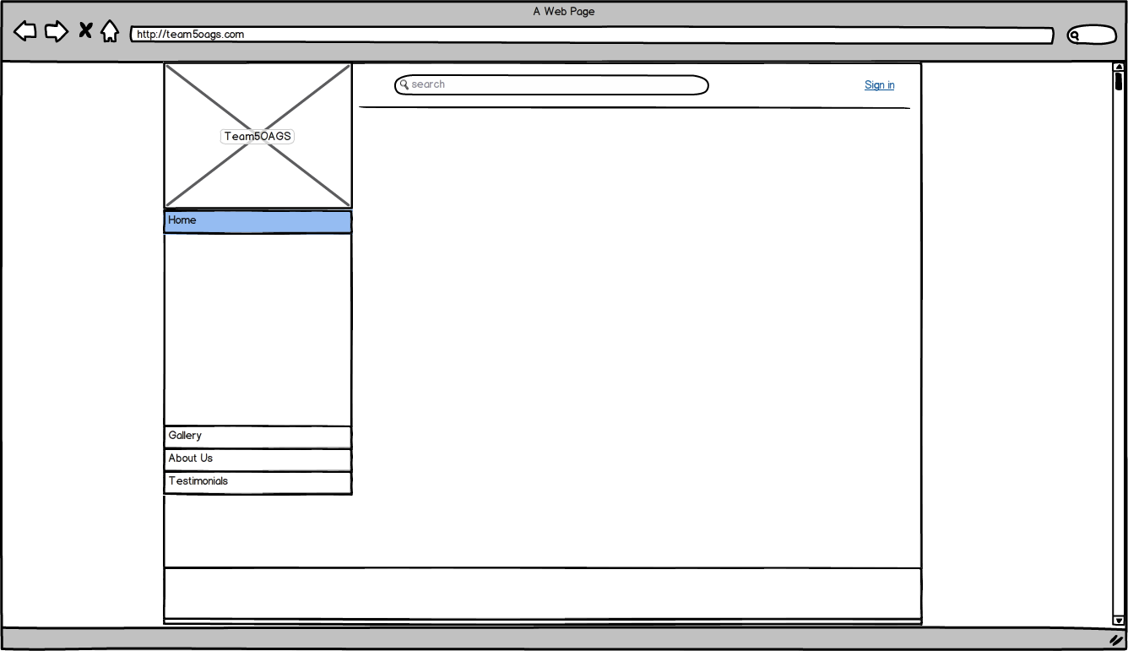

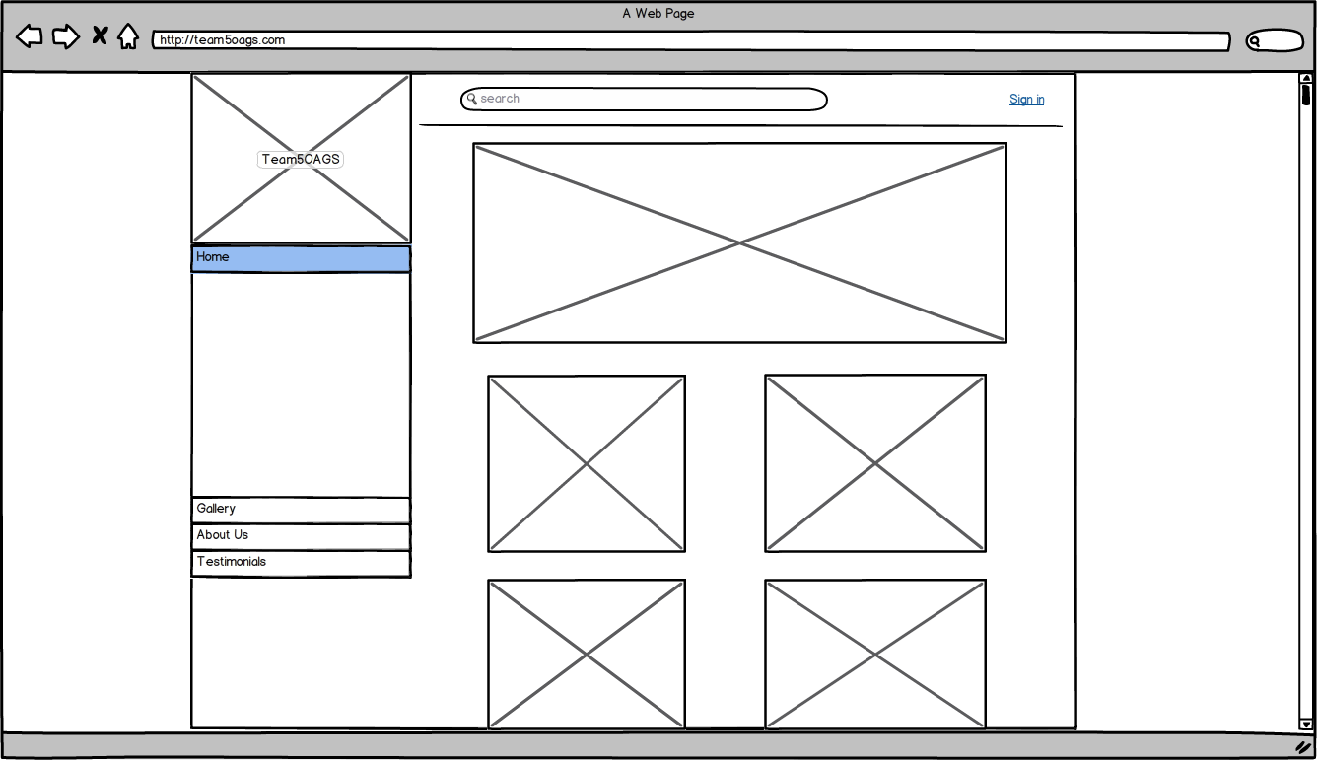

C. Concluding Remarks

The wireframes will help the client and intended users can examine and experiment with the prototype while the development team takes notes. The developers can change the prototype until both the client and the development team is satisfied that the client’s requirements are encapsulated in the rapid prototype.
Chapter IX: OO Analysis Models

- Problem Statement
In preparation for the Object Oriented Analysis Models, TEAM5 has spent a large portion of the Software development lifecycle meticulously planning all aspects of TEAM5OAGS. TEAM5 decided to use the waterfall methodology along with the Unified Modeling Language to analyze the full scope of the application. In doing so, TEAM5 identified seven entity classes, four major control classes, and 4 major boundary classes which take the information that has been computed in the control classes and acts as the views in MVC format for the user to interact with.

- The UML Diagrams
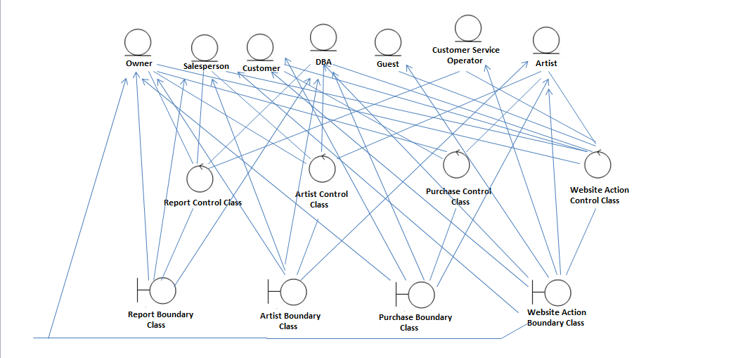

- Concluding Remarks
TEAM5OAGS will go live with all of the modules and capabilities that have been requested. This is possible due to the strenuous analysis that the requirements have undergone. TEAM5 is prepared to begin developing the final product and has a very refined instruction set to follow. This will allow for little to no errors and a complete product in time for TEAM5 to meet the deadlines.

Chapter X: OO Design Models

(Develop TEAM5OAGS UML OO Detailed Design models)
- Problem Statement
After the OOA Models from the requirements phase of TEAM5OAGS application the next step is to refine the artifacts of the analysis models which include the implementation of the use cases and methods needed for TEAM5OAGS. Since TEAM5OAGS is being developed in Ruby on Rails most of our effort in refining the methods will be focused on the controller classes of the project as the View in default configuration in rails is typically converted to output html in run time. In the class diagram below we have included the methods for our Models and Controllers. We also took the liberty to include our pseudocode of the controller methods.

- The UML Diagrams

Controller
Model
View
ChatOperatorController
-requestOnlineChat
CustomerController
-createTestimonial
-viewTestimonial
Testimonial
-TestimonialID
-testimonialContent
-testimonialEnteredDate
DBAController
-addNewArtist
-addNewCustomer
-createAccount
Customer
CustomerID
lastName
firstName
street
city
state
zip
country
areaCode
phoneNumber
username
password
email
Artist
ArtistID
lastName
firstName
nationality
dateOfBirth
dateDeceased
username
password
email
testimonials
chat_lobby
<< update model >>
<< update view >>
<< update model >>
New_Artist_Form
New_Customer_Form

<< update view >>
<< update view >>

Controller
Model
View
OwnerController
-requestCustomersReport
-requestArtistsReport
-requestCustomerArtistsPreferencesReport
-requestSpeedofSaleReport
SalespersonController
-requestCustomersReport
-requestArtistsReport
-requestCustomerArtistsPreferencesReport
-requestPastPurchaseReport
-requestPastPurchasesArtworkLocationReport
Transaction
acquistionPrice dateAcquired salesPrice
askingPrice
dateSold
Artist
**Artist’s Attributes
Customer
**Customer’s Attributes
customers_report
artists_report
customer_artists_preferences_report
past_purchase_report
past_purchase_art_location_report
speed_of_sale_report
<< update model >>
<< update view >>
<< update view >>
<< update view >>
<< update model >>
<< update model >>
**Refer to the above model class with the same name to see the list of attributes
CustomerController
-requestArtistandWorksReport
-requestCurrentInventoryReport
Artist
**Artist’s Attributes
Work
WorkID
title
medium
description
copy
Controller
Model
View
OwnerController
-purchaseNewArt
-repurchaseArt
SalespersonController
-purchaseNewArt
-repurchaseArt
Work
**Work’s Attributes
Transaction
**Transaction’s Attributes
artist_and_work_report
current_inventory_report
<< update view >>
<< update view >>
<< update model >>
<< update model >>
purchase_new_art
repurchase_art
<< update view >>
<< update view >>
<< update model >>
**Refer to the above model class with the same name to see the list of attributes
Controller
Model
View
CustomerController
-buyArt
Work
**Work’s Attributes
Transaction
**Transaction’s Attributes
CustomerController
-loginAccount
-modifyAccount
OwnerController
-loginAccount
-modifyAccount
SalespersonController
-loginAccount
-modifyAccount
ChatOperatorController
-loginAccount
DBAController
-loginAccount
ArtistController
-loginAccount
Customer
**Customer’s Attributes
Employee
EmployeeID
role
username
password
email
log_in
buy_art
<< update view >>
<< update model >>
<< update view >>
**Refer to the above model class with the same name to see the list of attributes
modify_account
<< update model >>
<< update model >>

Pseudocode:
//UC1: requestCustomersReport
public void requestCustomersReport(string username)
// Display a report listing Customers’ Information
{
// If Login is Owner or Salesperson
//Request Customer Model to view:
//Last and First names
//Addresses(street,city,state,zip,country)
//Phone numbers(area code and phone number)
//Email addresses
}

//UC2: requestArtistsReport
public void requestArtistsReport (string username)
// Display a report listing Artists’ Information.
{
// If Login is Owner or Salesperson
//Request Customer Model to view:
//Last and First names of Artist
//Nationality
//DateOfBirth
//DateDeceased
}

//UC3: requestCustomerArtistsPreferencesReport
public void requestCustomerArtistsPreferencesReport (string username, int CustomerID)
// Display a report in which artists have appeal to which customers.
{
//If Login is Owner or Salesperson
//Request Artist to view:
//Last and first names of Artist
//WHERE Input CustomerID = CustomerID of Transaction AND workID of //Transaction = workID of Work AND artistID of Work = artistID of Artist
}

//UC4: purchaseNewArt
public void purchaseNewArt (string username, string lastName, string firstName, string nationality, string title, string medium, string description, date dateAcquired, double acquisitionPrice)
// A new piece of art is purchased and added to the inventory
{
//If Login is Owner or Salesperson
//Request new Work & Transaction to add & Artist to update:
//Data about the artist (Last name, First name, Nationality)
//Title
//Medium
//Description
//Acquisition date
//Acquisition price
}

//UC5: repurchaseArt
public void repurchaseArt (string username, string title, date dateAcquired, double acquisitionPrice)
// A new piece of art is purchased and added to the inventory
{
//If Login is Owner or Salesperson
//Request new Work & Transaction to add & Artist to update:
//Acquisition date
//Acquisition price
//WHERE Input title = title of Work AND workID of Work = workID of //Transaction
}

//UC6: requestPastPurchaseReport
public void requestPastPurchaseReport (string username)
// Report to examine past purchase data based on recent date of purchase so that // actor can devote more time to the most active buyers
{
//If Login is Salesperson
// Request Transaction & Customer to view:
//Date Sold
//Last & First Name of Customer
//Email Address
//WHERE CustomerID of Transaction = CustomerID of Customer
//ORDER BY dateSold DESC
}

//UC6: requestPastPurchaseReport
public void requestPastPurchaseReport (string username)
// Report to examine past purchase data based on recent date of purchase so that // actor can devote more time to the most active buyers
{
//If Login is Salesperson
// Request Transaction & Customer to view:
//Date Sold
//Last & First Name of Customer
//Email Address
//WHERE CustomerID of Transaction = CustomerID of Customer
//ORDER BY dateSold DESC
}

//UC7: requestPastPurchasesArtworkLocationReport
public void requestPastPurchasesArtworkLocationReport (string username)
// Report to identify the location of purchased artworks they have sold in the past
{
//If Login is Salesperson
// Request Transaction, Work & Artist to view:
//CustomerID
//Work ID
//Title
//Nationality
//WHERE workID of Transaction = workID of Work AND artistID of Work = //artistID of Artist
}

//UC8: requestArtistandWorksReport
public void requestArtistandWorksReport (string username)
// Report to provide a list of artists and their works that have appeared in the //gallery
{
//If Login is Customer
// Request Artist & Artwork to view:
//Last and First Name of Artist
//Nationality
//Work ID
//Title
//Medium
//Description
//WHERE artistID of Work = artistID of Artist
}

//UC9: requestSpeedofSaleReport
public void requestSpeedofSaleReport (string username, int artistID)
// Report to determine how fast an artist’s work sells and at what sales margin //given an artist Id
{
//If Login is Owner
// Request Transaction to view with calculation:
//Work ID
//Date Acquired
//Date Sold
//Sales Time = Date Sold– Date Acquired
//Sales Margin = Sales Price – Acquisition Price
//WHERE workID of Input = workID of Transaction AND dateSold != null
}

//UC10: requestCurrentInventoryReport
public void requestCurrentInventoryReport (string username)
// Report to display on web application with current inventory of gallery.
{
//If Login is Customer
// Request Transaction & Work to view:
//Work ID
//Title
//Copy
//WHERE dateSold of Transaction = null AND workID of Transaction = workID // of Work
}

//UC11: modifyAccount
public void modifyAccount (string username, string last, string first, string street, string city, string state, string zip, string country, string areaCode, string phoneNumber)
// Edit Information of their own accounts
{
//If Login is Customer
// Request Customer to update:
//Last and First names
//Addresses(street,city,state,zip,country)
//Phone numbers(area code and phone number)
//If Login is Salesperson or Owner
//Request Employee to update:
//Last and First names
}

//UC12: createAccount
public void createAccount (string username, string userID, string password, string email, string role)
// Forms to fill out to assign account information
{
//If Login is DBA
//If Account is created for Customer
//Request a new Customer and add:
//Username and Password
//Email Address
//If Account is created for Employee
//Request a new Employee and add:
//Username and Password
//Email Address
//Role
//If Account is created for Artist
//Request a new Customer and add:
//Username and Password
//Email Address
}

//UC13: addNewArtist
public void addNewArtist (string username, string last, string first, string nationality, date dateOfBirth, date dateDeceased)
// New artist information is added to the database
{
//If Login is DBA
// Request Artist to update:
//Last and First Name of Artist
//Nationality
//Date of Birth
//Date Deceased

}

//UC14: addNewCustomer
public void addNewCustomer (string username, string last, string first, string street, string city, string state, string zip, string country, string areaCode, string phoneNumber)
// New Customer information is added to the database
{
//If Login is DBA
// Request Customer to update:
//Last and First Name of Customer
//Addresses(street,city,state,zip,country)
//Phone numbers(area code and phone number)
}

//UC15: requestOnlineChat
public int requestOnlineChat ()
// Customer or Guest chats with customer service operator
{
// Establish a connection between users
// Accept Input from Customer or Guest or Customer Service Operator
// Display Input into Chat Box
//Return 1 if successful
//Else Return 0 if failed
}

//UC16: requestSearch
public void requestSearch (string query)
// Search keys are entered into the search text box and user requests search.
{
// Accept Input from User
// Returns all links of relevant pages.
}

//UC17: loginAccount
public bool loginAccount (string username, string password)
// Guest logs into website and verifies account if username and/or password is //correct
{
// Initiate Boolean for username
//Initiate Boolean for password
//Encrypt input password with key
//Username is true if username in the database exist
//Boolean for password = encrypt password of Input = = encrypt password of an //accountholder WHERE username of Input = = username of the same //accountholder

//If Boolean of username AND Boolean for password
//Return true;
//Else
//Return False;
}

//UC18: buyArt
public void buyArt (string username, date dateSold, double salesPrice, int CustomerID)
// Salesperson can sell art to customer after the customer has contacted the //Salesperson about purchasing the artwork. Record with the purchase date, //acquisition price, date acquired, sales price, asking price, and identity of the //purchasing customer are stored.
{
// If Login is Customer
//Request Transaction to update:
//Date Sold and Date Acquired
//Acquisition, Asking, and Sales Price
//CustomerID
}

//UC19: createTestimonial
public void createTestimonial (string username, string, testimonialContent, date testimonialEnteredDate)
// Customer can create a testimonial.
{
// If Login is Customer
// Request a new Testimonial and add:
//Testimonial Content
//Testimonial Date
}

//UC20: viewTestimonial
public void viewTestimonial ()
// Customer or Guest can view a list of testimonials.
{
// If Login is Customer
// Request Testimonial & Customer to view:
//Testimonial Content
//Testimonial Date
//First and Last Name of Customer
}

C. Concluding Remarks
TEAM5OAGS shall be designed with the principles of high cohesion and low coupling in mind. Each class shall be concerned only with its own responsibilities and all methods in each lass shall adhere to the single responsibility principle. This shall ensure that the product to be developed will be highly maintainable with high quality in mind. TEAM5OAGS shall be implemented with these designs in mind and in accordance to the MVC format.

Chapter XI: Deployment Diagram

(Develop TEAM5OAGS UML Package and Deployment models)
- Problem Statement
Before the deployment of TEAM5OAGS application, we have to consider the hardware components that each software components will be installed in (or deployed). The UML Deployment Diagram below shows the links between the hardware components and software components. The diagram also displays how different components connect and interact with each other.

- The UML Diagrams
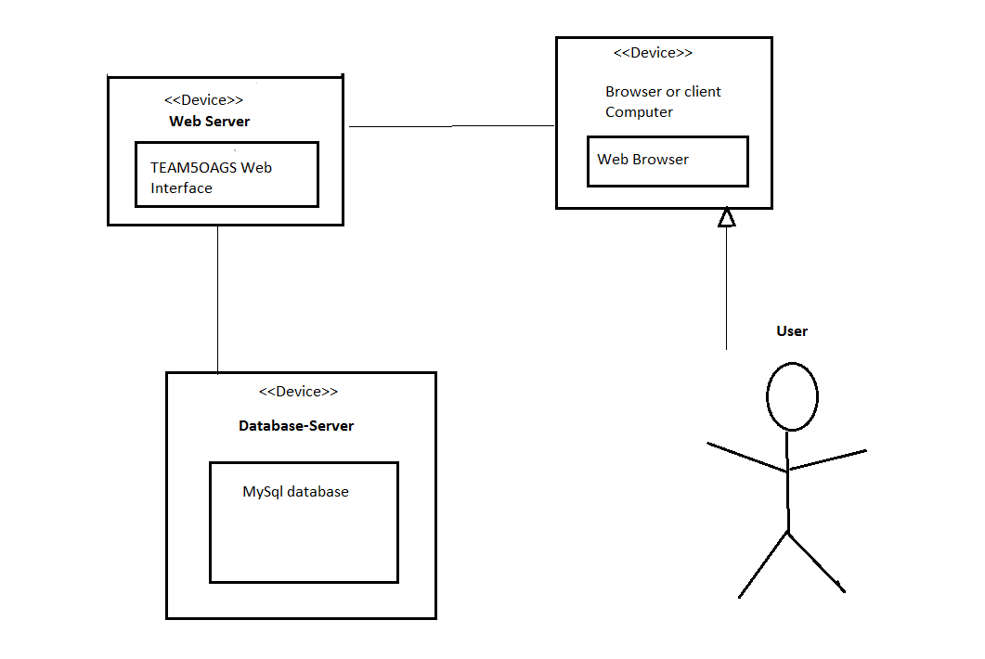

- Concluding Remarks
By following the deployment diagram above we listed all the hardware components and the software components used by TEAM5OAGS. We have also displayed what software component the hardware component will have installed, and how the hardware component interacts with others.

